Software Requirements Specification (SRS) Template

Project:
Version: 1.0
Authors: < Instructor / Student>
Date: 18-08-2025
Status: Model Answer / Approved

Revision history
Version | Date | Author | Change summary | Approval
1.0 | 18-08-2025 | Instructor | SRS with diagrams embedded

Approvals
Role | Name | Signature / Email | Date
Course Coordinator

Table of Contents
1. Introduction
2. Overall description
3. External interfaces
4. System features (detailed)
5. Non-functional requirements (detailed)
6. Quality attributes & Acceptance tests
7. UML Use-Case Diagram
8. Requirements Traceability Matrix (RTM)

1. Introduction

1.1 Purpose
The purpose of the Helping Hands software is to enable company employees, who are not regular mart workers, to volunteer in marts during weekends and festivals when customer footfall is high. It provides a platform for staff and managers to book time slots and select sections where they wish to assist. The software also awards Helping Hands Points (HHP) to users for their contributions, motivating participation.

1.2 Scope
The scope of the Helping Hands software is to provide a centralized platform that connects company employees with marts requiring additional support during weekends and festivals. The system allows staff and managers to search nearby marts, choose preferred sections, and book work slots based on availability.

1.3 Audience
1. End Users (Staff / Branch Managers / Company Employees): Members of the company who are not regular mart workers but volunteer to help in marts during weekends and festivals by booking slots and earning Helping Hands Points (HHP).
2.Store Admins: Individuals responsible for managing a specific mart, updating store details, defining section requirements, monitoring attendance, and managing user bookings.
3.Main Admin: The central authority with full system access who can register or remove users and stores, view detailed performance reports, and ensure smooth functioning of the overall system.
4.Secondary Stakeholders: System developers, testers, and management team who will design, maintain, and evaluate the software for usability, security, and scalability.

1.4 Definitions
- Helping Hands (HH): The initiative where company employees volunteer to assist marts during weekends and festivals.
- HHP (Helping Hands Points): Reward points earned by users based on the number of hours worked in a booked slot, used for performance tracking.
- Mart: A store location (mall, supermarket, electronics store, or other retail outlet) where users can book slots to assist.
- Slot: A specific time duration (with date and hours) that a user can reserve to work in a mart.
- Section: A specific area within a mart (e.g., billing, groceries, electronics, customer support) where volunteers can choose to work.
- Waitlist: A queue system where users are placed if their preferred slot or section is already full, ensuring fair allocation.
- FCFS (First Come First Serve): The principle used for assigning slots and waitlist positions based on the order of booking.
- Store Admin: The role responsible for managing mart details, sections, and user attendance.
- Main Admin: The central authority responsible for registering/removing users and stores, and monitoring system-wide performance.
- End User: Company employees (managers, technical staff, or other staff) who volunteer to work in marts.

2. Overall description

2.1 Product perspective
The Helping Hands software is a web-based, role-driven system that provides a structured way to manage volunteering activities in marts during weekends and festivals. It functions as an independent application but integrates with external services such as location APIs for nearby mart search and SMS APIs for notifications.
The system is designed around three distinct roles:
- End Users (company employees volunteering in marts),
- Store Admins (responsible for managing mart details and requirements), and
- Main Admin (responsible for system-wide administration).

2.2 Major product functions (detailed)
The Helping Hands software provides the following major functions, organized according to the roles of Users, Store Admins, and the Main Admin:
A. End User Functions (Staff / Branch Managers)
- Mart Search & Selection: Users can search for nearby marts using GPS/manual location entry and filter by type (mall, home essentials, electronics, etc.).
- Section Preference: Users can select a section in the mart (e.g., billing, groceries, electronics) where they wish to work.
- Slot Booking: Users can book a time slot of a chosen date and duration, subject to availability.
- Waitlist Management: If a chosen slot/section is full, the user can be added to a waitlist or choose another slot/section.
- Cancellation Policy: Users may cancel bookings, but only up to two cancellations are permitted per day.
- Booking History: Users can view their past, current, and upcoming bookings.
- Profile Management: Users can update and view their personal details.
- HHP Tracking: Users can view the Helping Hands Points earned for completed slots.
- Notifications: Users receive SMS alerts before the start of their booked slots.
B. Store Admin Functions
- Store Setup & Management: Store admins can define and modify store details, including size, type, and description.
- Section Management: Store admins can add, update, or remove sections and specify manpower requirements per section.
- Slot Booking Oversight: Store admins can monitor and interpret bookings made by users.
- Attendance Management: Store admins can track attendance of users during their allocated slots.
- Intake Limitation: Store admins can restrict the number of users per section or slot.
- User Booking Records: Store admins can access details of users who have booked slots in their mart.
C. Main Admin Functions
- User Management: Register new users or remove inactive/unauthorized users.
- Store Management: Register new marts or remove stores that no longer participate.
- Access to System Data: View user details, booking records, HHP performance, and store information.
- Performance Monitoring: Track and analyze Helping Hands Points to measure employee contribution.
- System Oversight: Ensure smooth operation of the system by controlling and monitoring all role activities.

2.3 User roles and characteristics (expanded)
1. End Users (Staff / Branch Managers / Company Employees)
- Role: Volunteer employees who are not regular mart workers but assist during weekends and festivals.
- Responsibilities:
  - Search and select nearby marts.
  - Choose preferred sections and book available slots.
  - Follow slot cancellation rules (maximum of two per day).
  - Earn and track Helping Hands Points (HHP).
- Characteristics:
  - Basic digital literacy (can use web or mobile app).
  - Motivated to support marts during peak times.
  - Prefer flexible timing and section choice.
2. Store Admins
- Role: Managers assigned to individual marts who manage bookings, store details, and user attendance.
- Responsibilities:
  - Maintain and update store details (size, type, sections).
  - Define manpower requirements per section.
  - Monitor user bookings and attendance.
  - Approve/deny waitlisted users if required.
- Characteristics:
  - Moderate technical knowledge.
  - Operationally responsible for ensuring smooth functioning of slots in their mart.
  - Must balance intake limitations with demand.
3. Main Admin
- Role: Central authority overseeing the entire Helping Hands system.
- Responsibilities:
  - Register/remove stores and users.
  - Access detailed records of user performance (HHPs) and store activities.
  - Monitor compliance with booking policies and fairness rules (FCFS).
  - Ensure system data is accurate and secure.
- Characteristics:
  - High-level system knowledge and decision-making authority.
  - Technical background to oversee performance and security.
  - Responsible for long-term sustainability and fairness of the platform.

2.4 Operating environment
The Helping Hands software will operate in the following environment:
- Platform:
  - Web-based application accessible via desktop and mobile browsers.
  - Mobile responsiveness for Android and iOS devices.
- Operating Systems:
  - Client side: Windows, Linux, macOS, Android, iOS.
  - Server side: Linux/Windows server environment.
- Database:
  - Centralized database (e.g., MongoDB or MySQL) to store user data, store details, bookings, sections, and Helping Hands Points (HHP).
- Networking Requirements:
  - Stable internet connection (Wi-Fi, 4G, or 5G).
  - Secure communication using HTTPS.
- Hardware Requirements:
  - Client side:
    - Smartphone with GPS support (for nearby mart search).
    - Desktop/laptop with at least 4GB RAM and modern browser.
  - Server side:
    - Minimum 8-core CPU, 16GB RAM, and scalable storage to handle peak festival/weekend load.
- External Services:
  - GPS/Geolocation API for nearby mart search.
  - SMS/Email API for slot reminders and notifications.

2.5 Constraints
- Operational Constraints:
  - The system will only be active and used during weekends and festivals, as per the Helping Hands strategy.
  - Slot allocation strictly follows the First Come First Serve (FCFS) principle.
  - Each user can cancel a maximum of two confirmed slots per day.
- Resource Constraints:
  - Limited intake per section or slot as defined by the Store Admin.
  - System performance may be affected if the number of concurrent users exceeds peak design capacity (1000+ users).
- Technical Constraints:
  - Requires stable internet connection for booking and notifications.
  - Location services (GPS or manual entry) are mandatory for mart search.
  - System must comply with role-based access (User, Store Admin, Main Admin).
- Regulatory & Security Constraints:
  - User personal data and location must be processed securely in compliance with data protection policies.
  - Location access must be opt-in and used only for nearby mart search, not for continuous tracking.
  - Data storage must support encryption and backup policies.

3. External interface requirements

3.1 User interfaces
- End User Interface
  - Search nearby marts (via GPS/manual entry).
  - Book/cancel slots and select sections.
  - View booking history, future bookings, and HHP points.
  - Receive SMS/alert reminders.
- Store Admin Interface
  - Modify store details and sections.
  - Manage slot bookings and user attendance.
  - Set intake limits and view user booking info.
- Main Admin Interface
  - Register or remove users and stores.
  - Access user details, store details, and HHP performance.
  - Monitor overall system activities.
UI Features:
- Role-based dashboards.
- Responsive design (mobile + desktop).
- Simple navigation and notifications.

3.2 Hardware interfaces

- Client Devices:
  - Smartphones (Android/iOS) with GPS support for location-based mart search.
  - Desktop or laptop with internet access and a modern web browser.
- Server Requirements:
  - Web server with at least 8-core CPU, 16GB RAM, and scalable storage to handle peak loads during weekends and festivals.
  - Reliable network interface for continuous availability.

3.3 Software interfaces
- Client Side:
  - Web browsers (Chrome, Firefox, Edge, Safari) for accessing the system.
  - Mobile OS support (Android/iOS) for responsive access.
- Server Side:
  - Application backend (e.g., Node.js/Java/Python).
  - Database (MongoDB/MySQL) for storing users, marts, bookings, and HHP data.
- External Services:
  - GPS/Geolocation API for nearby mart search.
  - SMS/Email API for sending booking alerts and reminders.

3.4 Communications
- Network Protocols:
  - HTTPS for secure client–server communication.
- Notifications:
  - SMS and Email APIs for slot reminders and alerts.
- Connectivity:
  - Requires stable internet (Wi-Fi, 4G, or 5G) for real-time booking and updates.

<< Make sure overall there are at least 15 FRs for overall project, 5 NFRs, 2 security objectives and 5 Security requirements>>

4. System features (detailed)
A. End User Features
- FR-1: The system shall allow users to search nearby marts using GPS/manual location input.
- FR-2: The system shall allow users to view details of a mart (type, size, available sections).
- FR-3: The system shall allow users to select a preferred section in a mart.
- FR-4: The system shall allow users to book available slots (date & time).
- FR-5: The system shall maintain a waitlist if the chosen slot/section is already full.
- FR-6: The system shall restrict slot cancellations to a maximum of two per day.
- FR-7: The system shall allow users to view booking history and upcoming bookings.
- FR-8: The system shall display the Helping Hands Points (HHP) earned by the user.
- FR-9: The system shall send SMS/email alerts to users before their slot begins.
B. Store Admin Features
- FR-10: The system shall allow store admins to modify store details (name, type, size).
- FR-11: The system shall allow store admins to add or remove sections and define manpower requirements.
- FR-12: The system shall allow store admins to view and manage user bookings.
- FR-13: The system shall allow store admins to mark attendance of users.
- FR-14: The system shall enforce intake limits set by store admins for slots/sections.
- FR-15: The system shall allow store admins to view user booking information for their mart.
C. Main Admin Features
- FR-16: The system shall allow the main admin to register new users and remove existing users.
- FR-17: The system shall allow the main admin to register new marts and remove existing marts.
- FR-18: The system shall allow the main admin to access user details, booking records, and store data.
- FR-19: The system shall allow the main admin to monitor HHP points and performance reports.
- FR-20: The system shall allow the main admin to oversee and monitor system-wide operations.

Non-Functional Requirements (NFRs)
- NFR-1: The system shall handle at least 1000 concurrent users during peak usage.
- NFR-2: The system shall be available with 99.5% uptime on weekends and festivals.
- NFR-3: The system shall provide a user-friendly and responsive interface for mobile and desktop.
- NFR-4: The system shall complete slot booking transactions within 2 seconds under normal load.
- NFR-5: The system shall be modular and maintainable for future updates and scalability.

Security Objectives (SOs)
- SO-1: Ensure the confidentiality and integrity of user personal and location data.
- SO-2: Ensure only authorized roles (User, Store Admin, Main Admin) access their respective functions.

Security Requirements (SRs)
- SR-1: The system shall provide secure login and logout mechanisms with password protection.
- SR-2: The system shall enforce role-based access control for different user types.
- SR-3: The system shall encrypt all sensitive data in storage and during transmission (HTTPS).
- SR-4: The system shall ensure location data is accessed only with user consent and used only for mart search.
- SR-5: The system shall perform regular database backups and support recovery in case of failure.

5.1. Security

5.1.1 Security Objectives
- Protect User Data Privacy:
Ensure the confidentiality and integrity of user personal information, including profile details and booking history.
- Control Access Based on Roles:
Guarantee that only authorized roles (End User, Store Admin, Main Admin) can access their respective functionalities, preventing unauthorized operations.

5.1.2 Security Requirements
1.Role-Based Access Control (RBAC):
The system shall enforce role-specific permissions for End Users, Store Admins, and Main Admins.
2.Secure Authentication:
The system shall provide secure login and logout mechanisms with encrypted credentials.
3.Data Encryption:
The system shall encrypt sensitive data (user details, HHP points, booking records) both in transit (HTTPS) and at rest.
4.Location Data Protection:
The system shall access user location only with explicit consent and use it solely for mart search, not for continuous tracking.
5.Backup and Recovery:
The system shall perform regular database backups and allow recovery in case of system or hardware failure.

6. Quality attributes & Acceptance tests
- Reliability:
  - The system must maintain 99.5% uptime during weekends and festivals.
  - Slot bookings must not be lost in case of server failure.
- Performance & Efficiency:
  - Slot booking transactions should complete within 2 seconds under normal load.
  - The system must support 1000+ concurrent users during peak hours.
- Usability:
  - The user interface shall be intuitive and responsive for both desktop and mobile devices.
  - A user should be able to book a slot in three or fewer steps.
- Security:
  - All user data and communications must be encrypted.
  - Only authorized users can access their respective role-based functions.
- Maintainability & Scalability:
  - The system shall be modular to allow easy updates.
  - It should support the addition of new marts, sections, and users without major architectural changes.

Acceptance Tests
- AT-1 (Location Search):
  - Given the user enables GPS or enters a manual location, when they search for marts, then the system shall display nearby marts sorted by distance.
- AT-2 (Slot Booking):
  - Given a slot is available, when a user selects a section and time, then the system shall confirm and display it in the user’s booking tab.
- AT-3 (Waitlist):
  - Given a slot/section is full, when another user attempts to book, then the system shall place them in the waitlist and notify them if a slot becomes free.
- AT-4 (Cancellation Rule):
  - Given a user has already cancelled two slots on the same day, when they attempt a third cancellation, then the system shall reject the request with a message.
- AT-5 (Notifications):
  - Given a user has a confirmed slot, when the slot start time is near, then the system shall send an SMS/email reminder to the user.
- AT-6 (HHP Points):
  - Given a user has completed a slot, when the store admin marks attendance, then the system shall automatically award and update HHP points in the user’s profile.

7. System models and diagrams

7.1 UML Use-Case diagram

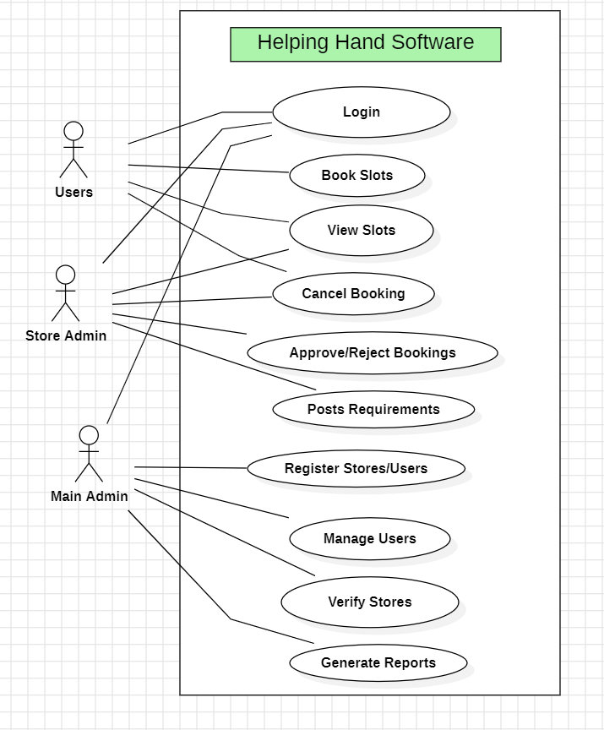

8. Requirements Traceability Matrix (RTM)

Requirement ID | Requirement Description | System Feature | Acceptance Test(s)
FR-1 | Search nearby marts using GPS/manual location input | End User Interface, Location Search | AT-1
FR-2 | View mart details (type, size, sections) | End User Interface | AT-1
FR-3 | Select preferred section in a mart | End User Interface, Section Preference | AT-2, AT-3
FR-4 | Book available slots (date & time) | Slot Booking | AT-2
FR-5 | Waitlist for full slot/section | Waitlist Management | AT-3
FR-6 | Restrict slot cancellations to max two/day | Cancellation Policy | AT-4
FR-7 | View booking history and upcoming bookings | Booking History | AT-2
FR-8 | Display earned Helping Hands Points (HHP) | HHP Tracking | AT-6
FR-9 | Send SMS/email alerts before slot begins | Notifications | AT-5
FR-10 | Modify store details (name, type, size) | Store Setup & Management | -
FR-11 | Add/remove sections; define manpower requirements | Section Management | AT-2, AT-3
FR-12 | View and manage user bookings | Booking Oversight | AT-2, AT-3
FR-13 | Mark attendance of users | Attendance Management | AT-6
FR-14 | Enforce intake limits for slots/sections | Intake Limitation | AT-3
FR-15 | View user booking information for mart | User Booking Records | AT-2
FR-16 | Register new users and remove existing users | User Management | -
FR-17 | Register new marts and remove existing marts | Store Management | -
FR-18 | Access user details, booking records, and store data | Access to System Data | -
FR-19 | Monitor HHP points and performance reports | Performance Monitoring | AT-6
FR-20 | Oversee and monitor system-wide operations | System Oversight | -
NFR-1 | Handle at least 1000 concurrent users during peak usage | Performance & Efficiency | -
NFR-2 | 99.5% uptime on weekends/festivals | Reliability | -
NFR-3 | Responsive, user-friendly interface for mobile and desktop | Usability | AT-2
NFR-4 | Slot transaction within 2 seconds under normal load | Performance & Efficiency | AT-2
NFR-5 | Modular and maintainable for scalability | Maintainability & Scalability | -
SO-1 | Confidentiality and integrity of user data | Security | -
SO-2 | Authorized roles only access permitted functions | Security | -
SR-1 | Secure login/logout mechanism with password protection | Security | -
SR-2 | Role-based access control | Security | -
SR-3 | Encrypt sensitive data in storage and transmission | Security | -
SR-4 | Location data accessed only with consent and for mart search | Security | AT-1
SR-5 | Regular backups and recovery support | Security | -

